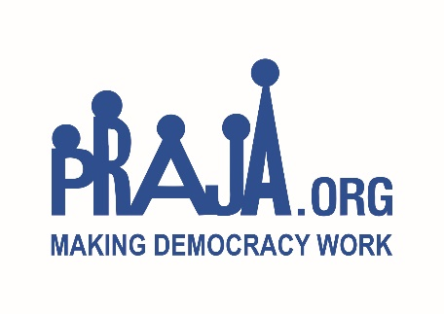

**Praja Foundation**

1st Floor, Victoria Building, Agiary Lane

Off Mint road, Fort, Mumbai 400001

Tel: 2261 8042 / 65252729

info@praja.org www.praja.org

Date: 4th July 2019

**Request for Proposal**

Praja is a nonpartisan organization working towards enabling accountable governance in Mumbai. Praja conducts Data driven research and provides information on civic issues to citizens, media, and government administration and works with elected representatives to identify and address inefficiencies in their work processes, bridge the information gaps, and aid them in taking corrective measures.  [www.praja.org.](http://www.praja.org/)

We are inviting proposals for Website Maintenance and for Website Enhancement during the period of July’19 to August’19. The period of work will be 1st September’19 to 31st March’20.

**Scope of service: Part 1: Website hosting & maintenance**

**1.Hosting and Management:**

CPU Cores: 4 RAM: 16 GB Drive: 60 GB SSD Bandwidth: 10 TB

* Intel Xeon E3-1270 v3 CPU
* 4 x 3.5 GHz Hyper Threaded Cores
* 8 MB Smart Cache
* 5 GT/s DMI Speed
* 2 IP addresses
* Centos 6.x 64 bit
* unlimited domains and user accounts
* 100 Mbps dedicated network uplink
* R1Soft Backups
* 24/7 customer support
* C Panel/WHM control panel
* 1 Gbps dedicated network uplink
* WHMCS
* NEWEDGE ClientExec
* Fantastico De Luxe
* Softaculous
* RVSkin
* Server Monitoring and alerts

**2.Maintenance (16 Hours x 6 Days):**

1. Resources/ Team:
2. Business Analyst: 1
3. Project Manager: 1
4. Development Lead: 1
5. Senior Developer - PHP: 1
6. Database Developer - MySQL: 1
7. Elastic Search Developer: 1
8. HTML/ Web Developer: 2
9. IT Administrator: 1

**Scope of Service: Part 2: Website Enhancement – Front End Revamp**

1. To improve the website navigation system and user interface (UI)
2. Redesigning the Home Page and Menu to enhance user experience.
3. Re-categorizing and tagging Praja’s work on the website as per the new structure and flow
4. In order to make the website more SEO friendly, incorporate Meta Title and Heading Tags
5. Indexing website pages to ensure deep-linking of the pages
6. **Scope of Work:**
7. Well experienced in Web development using PHP/MySQL with over 6 years of experience
8. 4+ years of work experience on Laravel Framework
9. Expertise on Elastic search is a must. Minimum 2 years of hand-ons experience
10. Experience of developing user friendly, mobile-ready, responsive websites
11. Knowledge of the latest trends in UI development using HTML5/CSS3, with expertise in jQuery
12. Must have performed successful Extract, Transform and Load (ETL) operations in the past
13. Experience in scripts and generating large reports of millions of records over a span of 10 years
14. Experience in Database optimization and storing/managing large sets of data

Please send the quotation on your letterhead mentioning the specifications of service and charges including taxes as applicable, via email or in a sealed envelope by 31st August, 2019. For any queries kindly contact Ms. Priyanka Sharma (+91-022 - 6525 2729) or Ms. Radhika Uppal. You can also e-mail us at [priyanka@praja.org](mailto:priyanka@praja.org) or [radhika@praja.org](mailto:%20radhika@praja.org)